The three following zip files each contain a solution that corresponds to an Building IG Outlook video series.

The igoutlookUnity 5 Implementing Navigation and a little MVVM.zip file correspond to a working solution for the Building IG Outlook Part 5 - Implementing Navigation and a little MVVM video, <https://www.youtube.com/watch?v=cSwubHHxEtk>, The demo code associated with video uses Infragistics third party controls, the code in the solution usez Telerik third party controls.

The igoutlookUnity 6 Adding Ribbon Tabs to View Navigation.zip file corresponds to a non working solution for the Building IG Outlook Part 6 - Adding Ribbon Tabs to View Navigation, https://www.youtube.com/watch?v=xH6OgCxdXQc,

igoutlook-part-6.zip

The igoutlook-part-6.zip file corresponds to a demo solution for the Building IG Outlook Part 6 - Adding Ribbon Tabs to View Navigation, https://www.youtube.com/watch?v=xH6OgCxdXQc,

The goal here is two fix the igoutlookUnity 6 Adding Ribbon Tabs to View Navigation solution so it performs as is shown at the end of the Building IG Outlook Part 6 video.

The solution is supposed to perform as follows.:

* First is to display a Ribbon Tab in the Ribbon when navigating to a child selection of the Personal Folder, and remove all preexisting Ribbon Tabs displayed.
* Second is when navigating to the Personal Folder remove all Ribbon Tabs displayed.

Each of the Personal Folders child selection is associated with a Ribbon Tab. When one of these child selections are selected a corresponding Tab is displayed in the Ribbon, and all preexisting Ribbon Tabs are removed. The Personal Folders selection is not associated with a Ribbon Tab. When the Personal Folders selection is selected all Ribbon Tabs are removed fron the Ribbon.

Below is how what should be displayed when navigating.

* Personal Folders selected

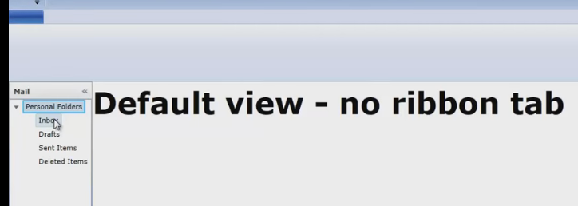

* Inbox selected

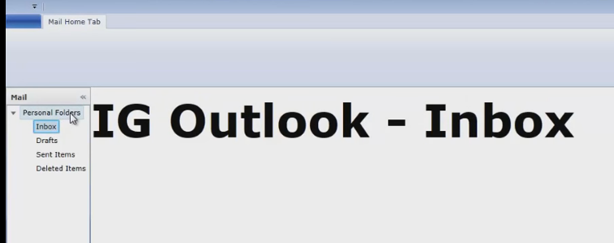

* Drafts selected

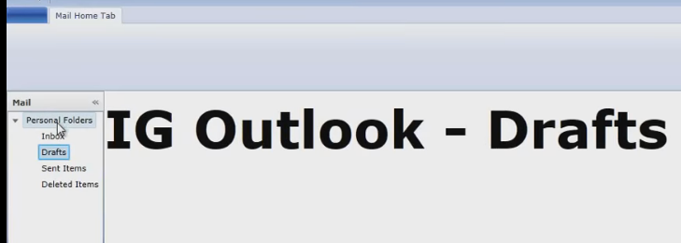

The igoutlookUnity 6 Adding Ribbon Tabs to View Navigation does not display this.

When the Inbox selection if fist selected no Ribbon Tab item is displayed. 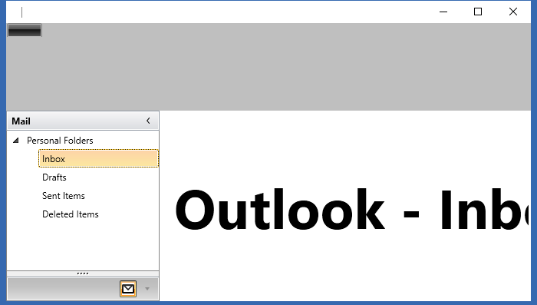

Next when clicking on the Drafts selection there is still no Ribbon Tab displayed, and Outlook – Inbox is still displayed. An exception is thrown when the ViewBase class’s OnNavigatedFrom(NavigationContext navigationContext) method is returned from.

The exception is caught in the RegionNavigationService class’s ExecuteNavigation(NavigationContext navigationContext, object[] activeViews, Action<NavigationResult> navigationCallback) method.

